Junhua Chang

This document provides detailed instructions on the process of building & testing Unity SDK.

Unity SDK Build & Test Guide

AT&T Developer Program

Contents

Prerequisites 2

How to build Unity SDK: 2

How to Test Unity SDK: 3

AvatarExample 3

UnityTutorial 5

# Prerequisites

Visual Studio 2012.

Unity 3D 4.01 or 4.5

# How to build Unity SDK:

Unity SDK has following components:

1) MSSDK DLL built with .NET 3.5

In the Application tab, change the Target Framework to .NET Framework 3.5.

Open MSSDK Solution in Visual Studio, then change target framework to .NET 3.5, Platform Target is x86 (for Windows), and build ATT_MSSDK.DLL. Then replace ATT_MSSDK.dll in Unity SDK folder (Plugins, Samples\AvatarExample\SourceCode\Assets\CharacterCustomization\DressingroomExample\Plugins, Samples\UnityTutorial\Assets\Plugins)

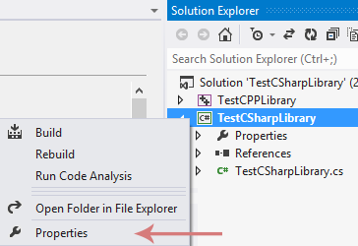

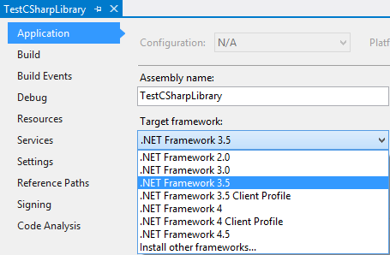

2) WaveGen.cs

3) Unity Sample (Samples\AvatarExample) & Tutorial Game (Samples\UnityTutorial)

4) Documentation

# How to Test Unity SDK:

Please pull the latest Unity SDK from github.

https://github.com/attdevsupport/ATT_APIPlatform_Unity_SDK

There are 2 samples:

## AvatarExample

https://github.com/attdevsupport/ATT_APIPlatform_Unity_SDK/tree/master/Samples/AvatarExample

This sample has been tested with Unity 4.01. Open the sample (AvatarExample\SourceCode) in Unity3d, click play, then:

===========================================================

Commands

===========================================================

Click/Touch 'Speech' button and say one of the following commands.

You have 5 seconds to say your command.

1) "Help"

2) "Change Character"

Character changes from boy to girl or vice versa

3) "Change to <color> <property>"

for example, "change to blue shoes and pink hair"

4) "Look at your shoes"

Character looks at own shoes

5) "That's a nice shirt"

Character turns head around and looks at own shirt in the mirror

6) "What do you think of your pants?"

Character turns head around and looks at own pants in the mirror

===========================================================

Colors possible for each combination of property and gender

===========================================================

Property |  Gender  |       Possible Colors

---------+----------+------------------------------------------

  Eyes   |   N/A    | blue, brown, green

---------+----------+------------------------------------------

  Head   |   N/A    | N/A

---------+----------+------------------------------------------

         |   Male   | blond, brown, orange, red

  Hair   +----------+------------------------------------------

         |  Female  | brown, cyan, dark, pink, red, yellow

---------+----------+------------------------------------------

         |   Male   | blue, gray, green, orange, pink, yellow

  Shirt  +----------+------------------------------------------

         |  Female  | blue, green, orange, pink, purple

---------+----------+------------------------------------------

         |   Male   | blue, dark, green, lillac, purple

  Pants  +----------+------------------------------------------

         |  Female  | black, blue, dark, green, orange

---------+----------+------------------------------------------

         |   Male   | black, brown, dark, green, red

  Shoes  +----------+------------------------------------------

         |  Female  | blue, green, red, yellow

---------+----------+------------------------------------------

## UnityTutorial

https://github.com/attdevsupport/ATT_APIPlatform_Unity_SDK/tree/master/Samples/UnityTutorial

This sample has been tested with Unity 4.5. Open the sample (UnityTutorial) in Unity3d, click play, then:

===========================================================

Commands

===========================================================

Press 'S' key and say one of the following commands.

1) "Red"

Cube changes color to red

2) "Green"

Cube changes color to green

3) "Blue"

Cube changes color to blue